SCIENCE 10

**Learning Activity Sheets BIODIVERSITY**

# Name Paul Gerald D. Pare

Section 9 - Adenine

## Background Information

Quarter 1: Week 5 Date 11/04/20

**Biodiversity** is the variety among living organisms from all sources, including terrestrial, marine, and other aquatic ecosystems and the ecological complexes of which they are part; this includes diversity within species, between species, and of ecosystems.

Scientists have recognized that life can be organized into several different levels of function and complexity. These functional levels are: ***species, populations***, ***communities***, and ***ecosystems***.

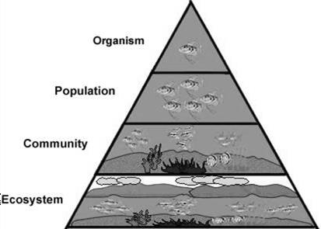

It refers to all the populations in a specific area or region at a certain time.

It is the dynamic entity composed of the biological community and the abiotic environment.

It comprises all the individuals of a given species in a specific area or region at a certain time.

It is a group of living organisms consisting of similar individuals capable of exchanging genes or interbreeding

## Population Size, Density, and Distribution

Communities are made up of populations of different species. In biology, a **population** is a group of organisms of the same species that live in the same area. The population is the unit of natural selection and evolution. How large a population is and how fast it is growing are often used as measures of its health.

## Population Size

It is the number of individuals in a population. For example, a population of insects might consist of 100 individual insects, or many more. Population size influences the chances of a species surviving or going extinct. Generally, very small populations are at greatest risk of extinction. However, the size of a population may be less important than its density.

## Population Density

It is the average number of individuals in a population per unit of area or volume. For example, a population of 100 insects that live in an area of 100 square meters has a density of 1 insect per square meter. If the same population lives in an area of only 1 square meter, what is its density? Which population is more crowded? How might crowding affect the health of a population?

To calculate the **population density**, you will divide the **population** by the size of the area. The unit of land area should be square miles or square kilometers.

*Population Density = Number of Species*

*Land Area*

## Population Distribution

It represents the average number of individuals per unit of area or volume. Often, individuals in a population are not spread out evenly. Instead, they may live in clumps or some other pattern. The pattern may reflect characteristics of the species or its environment. **Population distribution** describes how the individuals are distributed, or spread throughout their habitat.

**Patterns of Population Distribution**

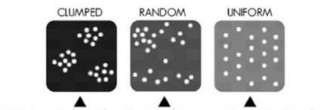

|  |  |  |  |  |
| --- | --- | --- | --- | --- |
| Organisms are clustered |  | Organisms have |  | Organisms are evenly spaced |
| together in groups. This | unpredictable | over the area they occupy. This |
| may reflect a patchy | distribution. This is | is typical of species in which |
| distribution of resources | typical of species in | individuals compete for a scarce |
| in the environment. | which individuals do | environmental resource, such as |
|  | not interact strongly. | water in a desert |

* Population size is the number of individuals in a population.
* Population density is the average number of individuals per unit of area or volume.
* The pattern of spacing of individuals in a population may be affected by the characteristics of a species or its environment

When a species’ population becomes so low that only few remain, the species is considered **endangered** and will possibly become extinct. In the Philippine, some terrestrial species like *tamaraw* in Mindoro, *mouse deer* in Palawan, *Philippine deer*, *Monkey-eating eagle* and aquatic species like the *dugong* found in Negros, Batangas and Leyte are in danger of extinction

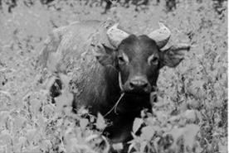

Tamaraw

Sometimes, there is a particular species that declines so fast that it becomes endangered and is said to be **threatened**. In a study conducted by field biologists on population size and distribution of Philippine fauna, they reported that as o 1991, 89 species of birds, 44 species of mammals and 8 species of reptiles are internationally recognized as threatened.

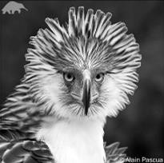

Philippine Eagle

These include also the Philippine Eagle or Monkey-eating Eagle in the list of Philippine Endangered Species.

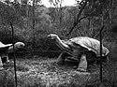

Luzon Giant Tortoise

**Extinction** is the disappearance of a species when the last of its members die. Changes to habitats can be threaten organisms with extinction. As populations of people increase, the impact of their growth and development is altering the face of the Earth and pushing many other species t the brink

of extinction.

**Key Concepts**

* Extinction occurs when the last member of that species dies.
* When the population of a species begins declining rapidly, the species is said to be a threatened species.
* A species is endangered when its population has become so low that it ispossible of becoming extinct.
* Human actions have resulted in habitat loss and degradation that have accelerated the rate of extinction.

**Local and Global Environmental Issues that Contributed to Species Extinction**

1. **Deforestation** is the permanent removal of trees to make room for something besides forest. This can include clearing the land for agriculture or grazing, or using the timber for fuel, construction or manufacturing. The following are the principal causes of deforestation.
   * **Kaingin farming** is employing a technique of clearing land by slashing and burning underbrush and trees and plowing the ashes under for fertilizer well- known kaingin system which has been enormously destructive of valuable timber
   * **Illegal logging** is the harvesting of wood that is in violation of national regulations. This could include harvesting timber from protected areas, felling protected species, or exceeding logging quotas.

## Conversion of agricultural lands to housing projects

* + **Forest fires**
  + **Typhoons**

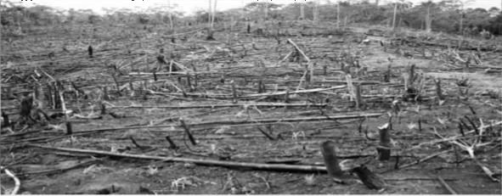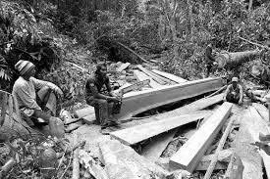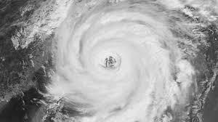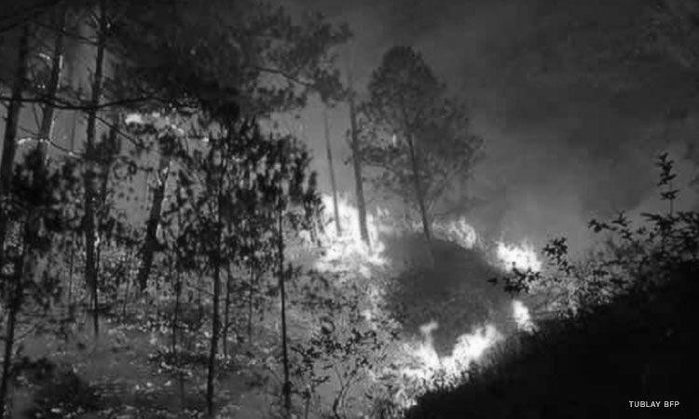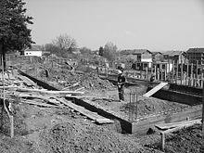

**Conversion of Land**

**Forest Fire**

**Typhoon**

**iIlegal Logging**

**Kaingin Farming**

1. 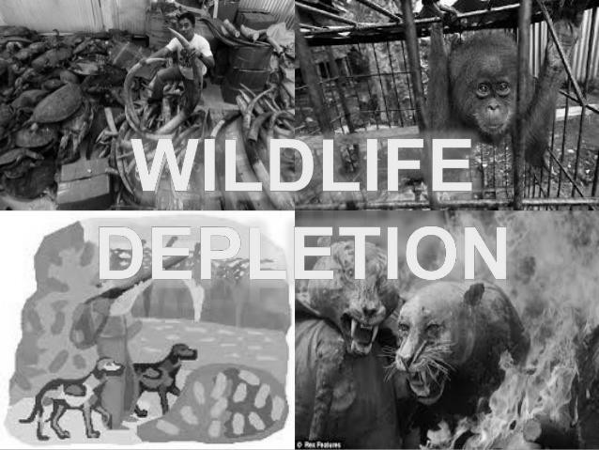**Wildlife depletion** Is the loss of wild animals through over hunting. Most often loss of their natural habitat due to human expansion of urbanization. The largest –scale killing of animals for food, trade and pleasure is one of the many causes for

the **depletion** of **wildlife**

1. **Water pollution** occurs when harmful substances—often chemicals or microorganisms— contaminate a stream, river, lake, ocean, aquifer, or other body of water, degrading water quality and rendering it toxic to humans or the environment.
   * 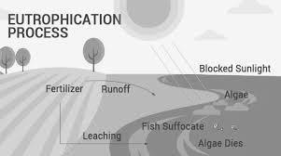**Eutrophication** is characterized by excessive plant and algal growth due to the increased availability of one or more limiting growth factors needed for **photosynthesis**, such as sunlight, carbon dioxide, and nutrient fertilizers

Eutrophication, is when a body of water becomes overly enriched with minerals and nutrients which induce excessive growth of algae. This process may result in oxygen depletion of the water body

1. **Air pollution** is a mixture of solid particles and gases in the air. Car emissions, chemicals from factories, dust, pollen and mold spores may be suspended as particles. Ozone, a gas, is a major part of air pollution in cities. When ozone forms air pollution, it's also called smog.

Some air pollutants are poisonous.

* + 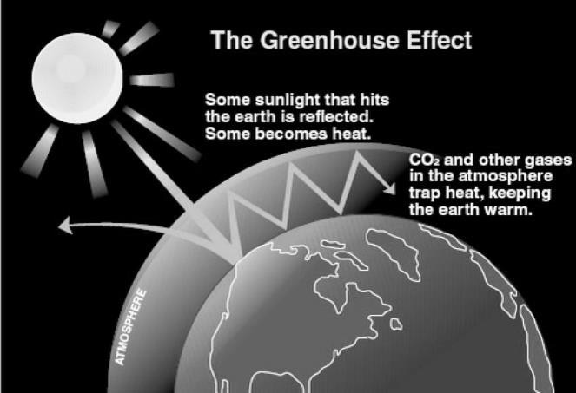Global warming is a gradual increase in the overall temperature of the earth's atmosphere generally attributed to the greenhouse effectcaused by increased levels of carbon dioxide, chlorofluorocarbons, and other pollutants. It is also driving changes in rainfall patterns, extreme weather, arrivals of seasons, and more.

The greenhouse effect is a process that occurs when gases in Earth's atmosphere trap the Sun's heat. This process makes Earth much warmer than it would be without an atmosphere.

## Destruction of Coastal Resources

**Coral reefs** are dying around the world. Damaging activities include coral mining, pollution (organic and non-organic), overfishing, blast fishing, the digging of canals and access into islands and bays Climate change, such as warming temperatures, causes coral bleaching,

which if severe kills the coral

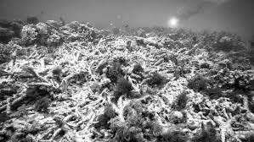 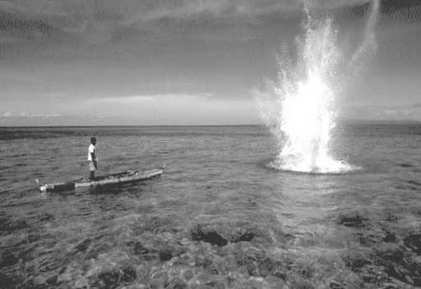

## Acid Precipitation

**Acid rain**, or **acid deposition**, is a broad term that includes any form

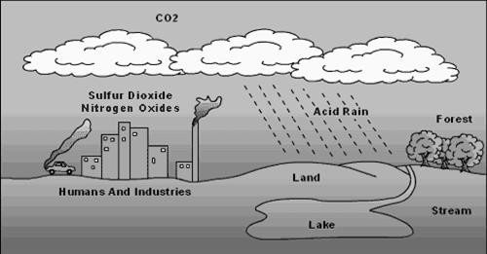of **precipitation** with **acidic** components, such as sulfuric or nitric acid that fall to the ground from the atmosphere in wet or dry forms. This can include rain, snow, fog, hail or even dust that is acidic.

Acid rain forms when water molecules in the atmosphere react with sulfur dioxide (from burning of coal and oil) or nitrogen oxides

(from burning of fossil fuels like gasoline) to form an acidic compound.

**Learning Competency**

Relate species extinction to the failure of populations of organisms to adapt and abrupt changes in the environment. (S9LT–Ie–f–30 wk 5)

## Activity No. 1. Measuring Population Density

0.15kg/m3

0.05kg/m3

0.04kg/m3

57 individuals

21 individuals

15 individuals

Bermuda Grass

Lilies

Clover

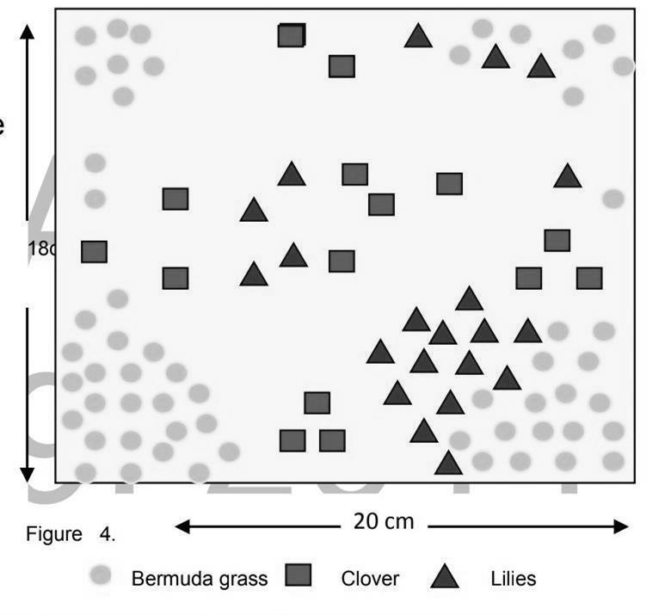

1.

2.

3.

18 cm

Study the three patterns of population distribution.

Compute for the area of a rectangle with a formula of

( A = lw )

Using the given formula for computing population density, calculate the density of each population.

4.

**Legend**

5.

**Population Name**

Density = No. of individuals

Size of area Count the total number for each population. Record the number in the table.

Calculate the density of each population with the same size of area. Record in the table.

**Number of Organisms Density**

1. What is the total population size? 93 plants in the size of that area.
2. Identify the type of pattern of distribution of each population. The pattern for bermuda grass, clumped. For clover and lilies are random.
3. Which population has the greatest density? The population that have the highest density is the Bermuda grass.
4. Infer from the recorded data from the possible causes for the differences in the population density. The amount of plants in a given area and the density of it is directly proportional to each other.
5. What conditions could change the density of any of the population? Amount of plants in the same type in a given area.
6. Describe how a population’s density can be used to learn about the needs and characteristics of that population. If there is higher density of a plant in an area then people will try to sell them at cheaper prices. If the plant is hazardous or wild, then people wouldn’t want to live in that area.

## Activity No. 2- Multiple Choice.

**Directions:** Choose the correct answer. Write the letter that corresponds to your answer on the space provided before each number.

B 1. What refers to the variety of life in an area?

* 1. Biology C. Density
  2. Biodiversity D. Population

C 2. What is the correct level of organization from narrow to broad?

1. Community---Ecosystem----Organism Population
2. Ecosystem----Community---Population Organism
3. Organism-----Population----Community Ecosystem
4. Population----Organism-----Ecosystem Community

A 3. What is the difference between endangered and extinct with regards to species?

1. Endangered means less in number and extinct means no longer exist
2. Endangered means no longer exists and extinct means less in number
3. Both are similar
4. No differences

A 4. The average temperature of the earth’s atmosphere may rise as a result of

1. Greenhouse effect C. Water pollution
2. Typhoon D. Weather

D 5. Suppose 150 grasshoppers lives in 15 sq.m. plot of grass. What would be the population density of the grasshoppers? (per sq. m)

1. 2250 grasshoppers C. 100 grasshoppers
2. 135 grasshoppers D. 10 grasshoppers

A 6. If 80 goats live in 4 1/2 sq. km. area. What is the population density per sq.km?

1. 18 goats/sq.km C. 360 goats/sq.km
2. 75.5goats/sq.km D. 804.5 goats/sq.km

C 7. A process where nutrients are washed away from the land to enrich bodies of water, causing excessive growth of aquatic plants and algae and results in algal bloom, which depletes the oxygen dissolved in water, causing fish and other aquatic organisms to die.

1. Acid Rain C. Eutrophication
2. Deforestation D. Kaingin System

A 8. The major human causes of extinction today are the following **EXCEPT.**

1. captive breeding C. high population demand
2. habitat destruction D. overexploitation

D 9. Which of the following is **NOT** considered a human act causing environmental issues?

1. Acid Precipitation- Acid Rain C. Eutrophication- fish kill
2. Deforestation-illegal logging D. Greenhouse Effect-planting trees

D 10. Which group of organisms are more prone to extinction?

1. Those with specialized diet C. those with high reproductive rate
2. Those with less commercial value D. those with smaller size of offspring

## Activity No. 3. Think of It

1. All organisms have the inherent right to exist. Would you extend this right to an infectious bacteria or the mosquito that transmits dengue? Why or why not? Yes, but not in our city nor in barrio, they should be in wild and people shouldn’t live there. They are still organisms, if they didn’t exist then our ecosystem is imbalance.
2. Suppose that your best friend wanted to buy a tarsier as an exotic pet. What suggestions will you tell your friend before he buys it? Is buying an exotic pet a good idea? Why or why not? It is a good idea in my opinion, because if he bought that then his intentions is to release them in their natural habitat. Because if he didn’t bought it, then other people could buy it and resell or kill the tarsier.
3. If you will be in-charge of preventing the premature extinction of organisms, what would be the top three (3) priorities in your program? Release and take care of them in their natural habitat, breed them to populate their species, protect their habitats.

## Reflection

If you will be assigned as the secretary of the Department of Environment and Natural Resources (DENR). How will you address the local environmental issues?

I will prioritize the banning of illegal mining in the Philippines because it is one of the main cause of environmental lost in the philippines. Our country is have many illegal mining sites. In also causes sickness to residents.It doesn’t only affect our environment but also other animals and humans. There are many toxins in it that people need to evacuate and move to other places. These illegal mining sites should be banned and be removed. As early as 1521, Filipinos are already mining to find treasures such as gold. It has negative and irreversable effects to our environment and our health.

## REFERENCES

Bayquen A. et al. Exploring Life Through Science, Phoenix Publishing House, 2014pp 98- 117 Avila, V.L. Biology: Investigating Life on Earth (2nd ed.) Boston, MA Jones and Barlett Publishing House (1995)

Greenfacts.org, Biodiversity, Accessed August 25, 2020. https://[www.greenfacts.org/en/biodiversity/l-3/1-define-](http://www.greenfacts.org/en/biodiversity/l-3/1-define-) biodiversity.htm <http://www.physicalgeography.net/fundamentals/9d.html>

Libretexts, Ecology, Accessed August 25, 2020. https://bio.libretexts.org/Bookshelves/Introductory_and_General_Biology/Book%3A_Introductory

_Biology_(CK- 12)/06%3A_Ecology/6.17%3A_Population_Size%2C_Density%2C_and_Distribution

Inquirer, Endangered Species, Accessed August 25, 2020. https://pop.inquirer.net/74580/time- is-running-out-for-these-critically-endangered-species- in-the-philippines

Nature.com, Eutrophication, Accessed August 25, 2020. https://[www.nature.com/scitable/knowledge/library/eutrophication-causes-consequences-](http://www.nature.com/scitable/knowledge/library/eutrophication-causes-consequences-) and- controls-in-aquatic-102364466/

## KEY TO CORRECTION

Activity No. 1 Measuring Population Density

|  |  |  |
| --- | --- | --- |
| **Population Name** | **Number of Organisms** | **Density** |
| Bermuda | 55 | 1.53 |
| Clover | 14 | 0.04 |
| Lilies | 19 | 0.05 |

1. 88

* 1. Bermuda – Clumped, Clover – Random, & Lilies – Random
  2. The Bermuda grass has the greatest density
  3. Answers may include: availability of sunlight, nutrients, or water; presence of other organisms that feed on the plants; the space available to each individual plant
  4. Answers may vary. Any change in the factors listed in question no. 4 could lead to change in population density
  5. Population density is based on the relationship between the needs of the individual species and a complex mix of limiting factors. Differences might point to potential problems such as pollutants or disease.

Activity No. 2. Multiple Choice

1. B 6. A
2. C 7. C
3. A 8. A
4. A 9. D

5. D 10. D